Pages / Rev.io Con×guration Guide

Reseller Setup

Created by Leslie Ingram, last modi×ed on Sep 21, 2017

Overview

When Rev.io clients have Resellers that need a way to bill their end-users, Rev.io offers our Reseller or White-label model. This con×guration consists of a Primary instance for the Rev.io client and then a secondary or reseller instance which will be a multi-tenant database that your clients can use to bill their end-users. The functions of each are listed below:
Primary

This is where you, the Rev.io client, bill the reseller for all MRCs and Usage that they are reselling. This is where you can bill direct buyers like your business or residential customers.
You will con×gure your primary site with the assistance of Rev.io during your implementation.

Secondary or Reseller Instance

This is where your Resellers create, manage, bill and remit payments for their customers. Multiple resellers share this site.
You, our Rev.io client, are responsible for the setup and administration to this site. Resellers have restricted access and can only create and manage their accounts. The reseller cannot do any setup to this site. It is just a billing system to them.

The Secondary instance must be properly con×gured with a Bill Pro×le and Agent Pro×le for each Reseller to give them the proper access to just their accounts. These are the most important of the settings. The person(s) designated as your administrators must repeat ALL the instructions below for each new Reseller to add them to your Secondary or Reseller instance of Rev.io to complete their setup.

Pre-Setup Information Request Checklist

Before setting up a Reseller in Rev.io, you will need to request the following information from them. You will need this information to complete their setup.

Logo
Product Catalog - You may be using a standard set of products for all your resellers, if so you may just need their rates for the product catalog. Each reseller can have unique product sets though. You will be responsible as the Administrator of their site for setting these up though.
Long Distance Usage Rates - You may be using a deck of standard rates for all your resellers. If so, you do not need this from the client. Remit Address for payments made by mail.
Language for email and "from email address" for Payment con×rmation emails Language for email and "from email address" for Bill noti×cation emails Language for email and "from email address" for Auto Debit failures
Language for email and "from email address" for other noti×cations like Billcenter.net setup or account activation
List of users that need access to their accounts

Setup

Several con×guration items must be setup for each reseller item. These must be associated with either the agent pro×le or the bill pro×le to tie it back to the Reseller. Here is an example. The products that are loaded in the product catalog must be restricted to the Resellers' Bill Pro×le. By doing this, you ensure that the other Resellers in Rev.io do not see their products. Another example is the EBPP pro×le. You will set up one of these for each Reseller and tie it to the Bill Pro×le on the Email Tab. This way you can have a different email and different logo on that email for each Reseller. The full list of settings, as well as the instructions for setup of each item, are found in the following pages.
Reseller Impacting Con×guration Item Checklist

Logo
Bill Pro×le
Payment Method/Merchant Account
Email Templates - Email Templates Tab
Auto Debit Failure Email
Bill Noti×cation Email
Payment Received Email Noti×cation
Password Reset
Billcenter Registration
New Billing Platform Announcement
Password Reset
Agent Pro×le attached to the correct Bill Pro×le
Report Category for Each Reseller
Rev.io Permissions
Reseller Role (Copy for each reseller) Users attached to the correct Agent Pro×le Billcenter.net Setup
Products and Packages
Usage Rates and Usage Plan groups

Bill Profile

The Bill Pro×le is what Rev.io considers the brand and/or the billing rules for each Reseller. When you launch a reseller you must create a unique Bill Pro×le for them in the shared reseller instance. You will then place a ticket with Rev.io that has their logo attached so that we can make the connection between the Bill Pro×le and the logo on our side. Instructions for setting up the Bill Pro×le are listed below. You may not be able to complete your bill pro×le setup all at once. You can begin and update as you get all the information.

Bill pro×le settings include billing cycle rules, branding options, collection templates, BillCenter.net speci×cations and fees.

1. To create a bill pro×le go to the Settings menu and select the Bill Pro×les link in the menu.

On this page:

Billing Rules

The terms of the customer's billing are speci×ed under the Cycle Settings and Cycles sections of this page.
Cycle Settings
Cycles
Settings
Merchant Pro×les
Address Printing Email Collections Messages Orders States

2. Click the New button to create a new pro×le or select an existing pro×le by clicking the name of the pro×le to edit.
3. Next, select the settings under each tab for the pro×le you wish to create.

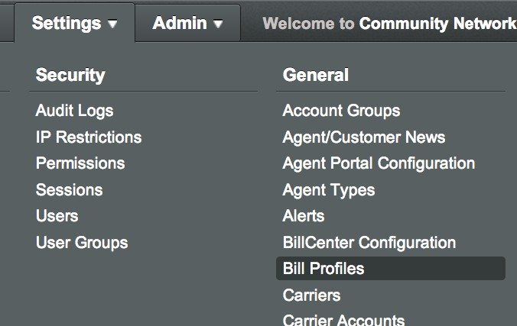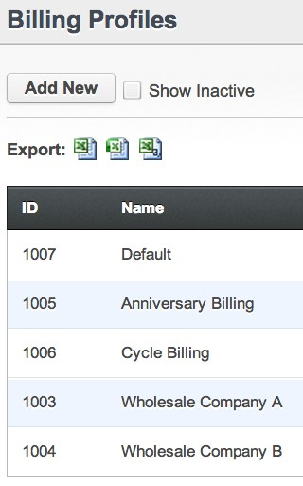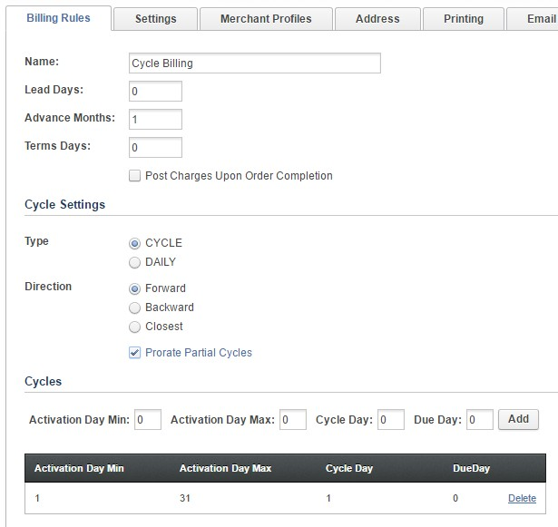Billing Rules

The Billing Rules tab contains numerous settings related to the billing rules of the account.

 When naming the pro×le, use a Name that will summarize or specify the content of the pro×le.

The Lead Days ×eld can be used to add a number of days the statements can be generated prior to the actual cycle date.
The Advance Months ×eld is used to specify the number of billed months ahead of the current month that an account will be billed. Leave a "0" if billing the previous month's charges. Set to “1” if billing the current month’s charges.

The Terms Days ×eld is used instead of selecting a speci×c due date for the customer's statement. If setting a due date, leave this ×eld blank. The term days is the number of days the bill will be due after the cycle date.
The Post Charges Upon Order Completion ×eld is used if you would like charges to post to the account once an order is complete, rather than immediately posting.

The terms of the customer's billing are specified under the Cycle Settings and Cycles sections of this page.

Cycle Settings

1. Select a Type.
Cycle – Allows for one or multiple monthly cycles to be set.
Daily – The customer's activation date becomes their cycle date. Also know as anniversary billing.
2. Select a Direction.
Forward – For Cycle Billing, this option affects the initial bill. If you activate early in the month and want to charge proration for the current month and the next month then choose this option. E.G Current cycle is 10/1. Customer activates on 9/2. On 10/1 the customer receives a bill for 9/2 through 9/30 and (if advance month is 1) 10/1 through 10/31.
Backwards – For Cycle Billing, this option affects the initial bill. If you activate early in the month and want to charge the proration at the time of activation you can send the customer an initial bill immediately. E.G - Customer activates on 9/2. Charges will show up immediately on the unposted tab for 9/2 through 9/30 so you can generate a bill to the customer immediately. On 10/1 they will cycle with all others and be charges for 10/1 through 10/31. This is an option so that you can prevent initial bill sticker shock.
Closest – Select this option to just select the closest cycle date.
3. Prorate Partial Cycles - Select to prorate charges when using the Cycle option.

Cycles

If using the Cycle type, set the Cycles up at the bottom of the screen.

a. The Activation Day Min is the ×rst day the customer will be placed on a cycle day. b. The Activation Day Max is the last day the customer will be placed on a cycle day. c. The Cycle Day is the actual day the customer's charges will cycle.
d. The Due Day is the due date printed on the customer's statement.

 Multiple cycles can be set during a month so that different groups of customers can receive a bill during periodic times of the month. An example of one monthly cycle is included below.

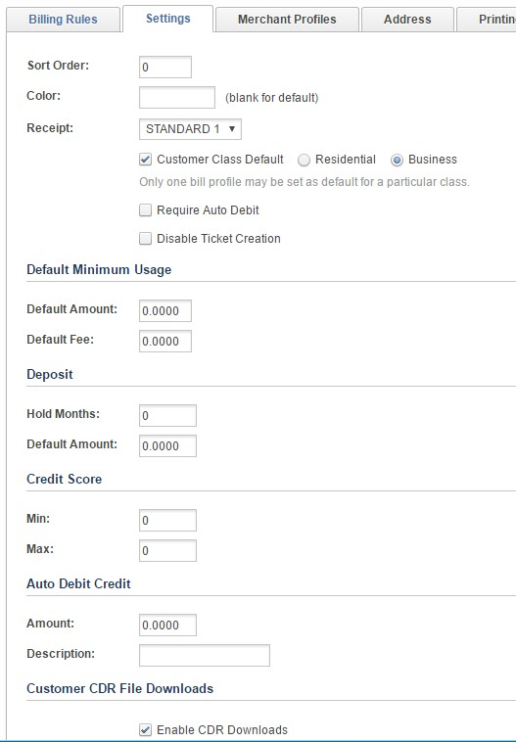Settings

The Sort Order and Color are optional ×elds that allow you to specify the order the pro×les appear and the color of the text for the pro×le name as it appears in the customer pro×le. The Receipt ×eld can be left to the default option unless a custom payment receipt is required for the customer.
The Class Default option needs to be set to the type of account that will be entered most often when using this pro×le.
Select Require Auto Debit if customer accounts will be required to provide auto debit information. Leave unchecked if this is not supported or required. Select Disable Ticket Creation if the customers will not be able to create trouble tickets.

The Default Minimum Usage ×eld will allow the user to set a minimum billed amount for the customer.
The Deposit ×elds allow for specifying a number of hold months and default amount required for deposit per bill pro×le. Ignore Credit Score ×eld unless integrated with a 3rd party provider.
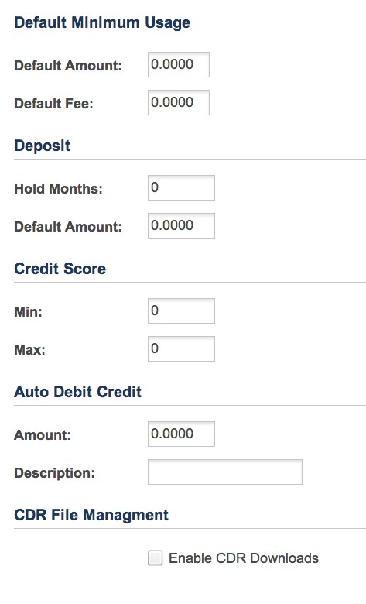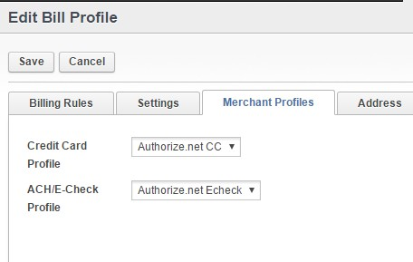The Auto Debit Credit ×eld allows for a recurring credit to be added to an account each month if the customer pays by Auto Debit.
Select Enable CDR Downloads under the CDR File Management section to allow customers to download usage records.

Merchant Profiles

This section is only applicable when processing payments electronically in Rev.io. Available Merchant Pro×les can be designated per Bill Pro×le for Credit Card and E-Check processing.

Address

The remit address is speci×ed in the Address tab.

By default, Remit Address is selected as the option and you can enter your remit address to print on your bills.

Optionally, you can select the Message option and personalize that and the message will print on the bill instead of the remit address.

Printing

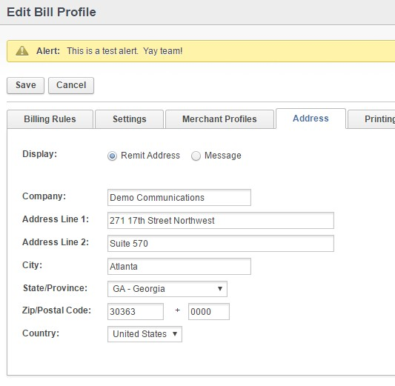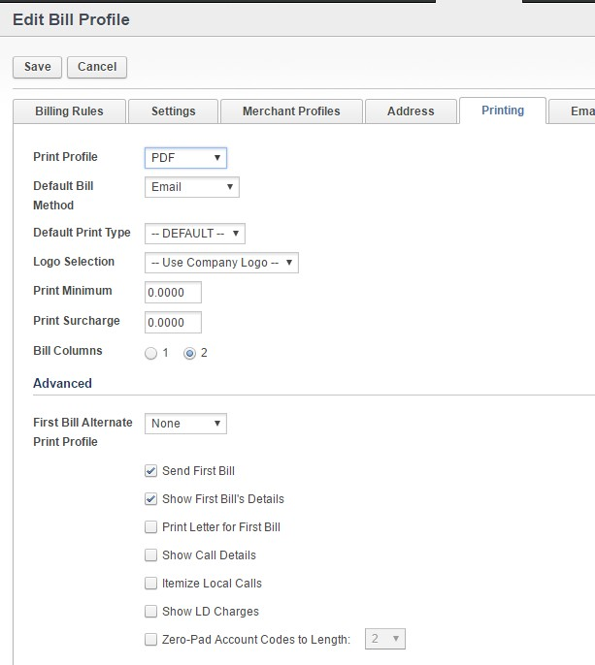The Printing tab settings are used to set a variety of options. Some of these options are only applicable to certain types of providers.

Print Pro×le – This ×eld defaults to PDF. Do not change this default unless speci×ed to do so by Rev.io. This ×eld is used when working with a 3rd party print vendor.
Default Bill Method – This can be adjusted to change the default bill receipt method on new customers.
Default Print Type – This cannot be adjusted in most cases. Do not change unless speci×cally told to do so by Rev.io. This ×eld is used when working with a 3rd party print vendor.
Logo Selection - Allows user to select from multiple logos if desired
Print Minimum – Enter an amount in this ×eld to set a minimum bill amount for printing a statement.
Print Surcharge – Set an amount in this ×eld to apply a print surcharge to a statement.
Bill Columns - Select 1 or 2, depending on whether you want single column bill or double column bill.

Under the Advanced section:

First Bill Alternate Print Pro×le - Ignore unless speci×cally directed by Rev.io to use this ×eld.
Send First Bill – Ignore unless speci×cally directed by Rev.io to use this ×eld.
Show First Bill's Details – Ignore unless speci×cally directed by Rev.io to use this ×eld.
Print Letter for First Bill - Ignore unless speci×cally directed by Rev.io to use this ×eld.
Show Call Details – This option is no longer used. Call details are managed at the customer account level. Itemize Local Calls – This option is no longer used. Call details are managed at the customer account lev Show LD Charges – This option is no longer used. Call details are managed at the customer account level.

Zero-Pad Account Codes to Length - Ignore unless speci×cally directed by Rev.io to use this ×eld.

Email

If any Automated Emailing options are selected, con×gure this here.

Email templates can be con×gured under the Settings tab > Email Templates link.

Collections

In the Collections tab the user can select the Collections Template associated with each pro×le. Templates are pre-con×gured under the Settings tab on the Collection Templates link.

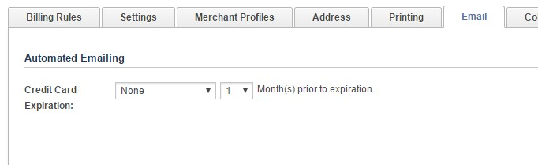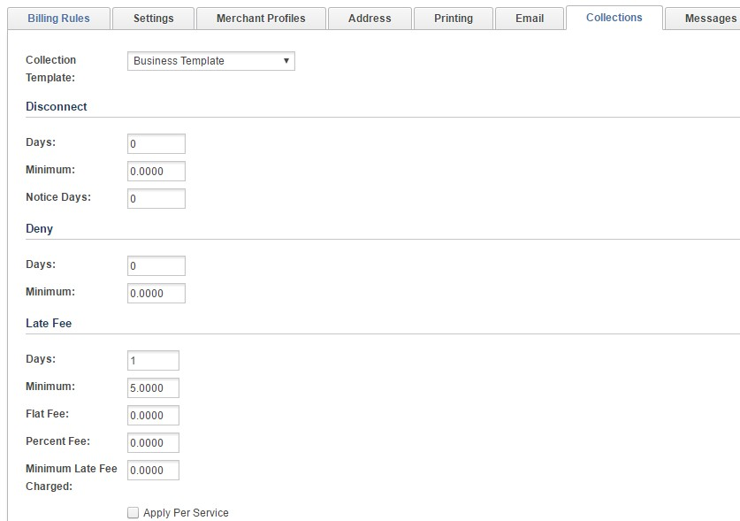Disconnect – De×ne the terms and amount of fees applied when a disconnect occurs on an account.
Deny – De×ne the terms and amount of fees applied when a deny or suspend order is issued on a customer's account.
Late Fees -

Days - Select the number of days after the due date to apply the late fee.

Minimum - Select the minimum balance for a late fee to apply. Can be zero or a selected minimum amount

Flat Fee or Percent Fee - Late fees can be either a Øat fee or percentage fee. Minimum Late Fee Charge - A minimum fee charge can also be speci×ed. Apply Per Service - You can apply one late fee or one per each service
Late Fee Exception 1 & 2 - Up to two late fee exemptions are also supported in this section. Late fee exemptions can be added at the state level.

Early Termination – Set a standard fee that will be added to a customer's account if the customer terminates a contract early.
Bounced Payment – Specify the fee and description that will be added to the customer's account when a payment is marked as Bounced.

Messages

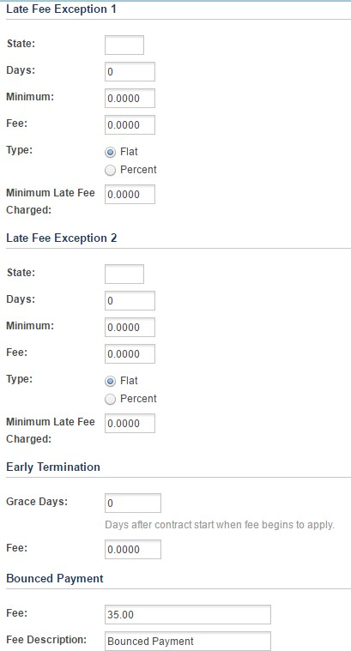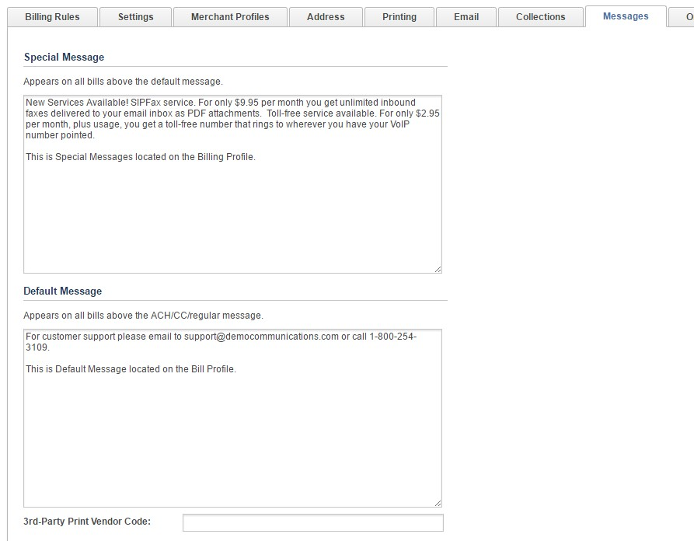Within the Message tab, custom messages can be created for display on all customers' statements that are a member of that bill pro×le. There are multiple options for creating messages and you can con×gure more than one message to show... they will all show in boxes at the top of the Bill and will just stack on top of each other.

The Special Message appears at the top and the Default Message would appear under that.

The ACH Message shows for just those customers enrolled in Auto Debit for ACH/E-Check and the CC Message shows for just those customers enrolled in Auto Debit with a Credit Card.

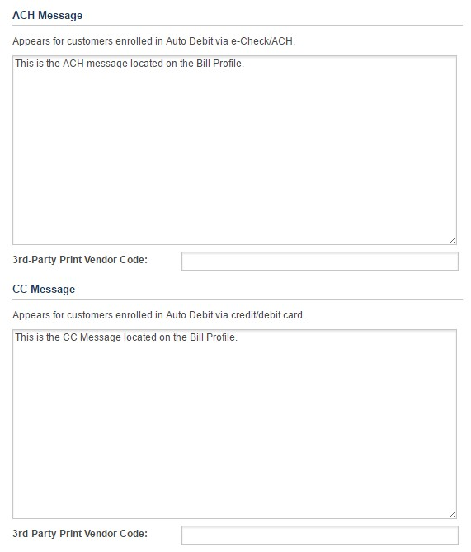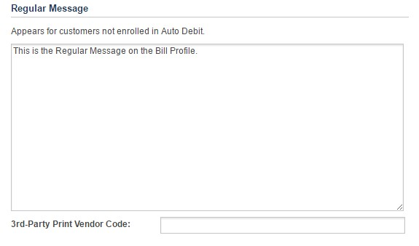As an alternate, the Regular Message would go out to the customers that are NOT enrolled in any form of Auto Debit.

Orders

Fees related to the order process can be con×gured under this Tab. Leave at 0.00 where not applicable. These fees are automatically applied to the account when these options are selected in the Change
Order Wizard in Rev.io.

Minimum Payment Policy -

Other Settings - Check the Prorate Disconnects box if you would like to enable that functionality

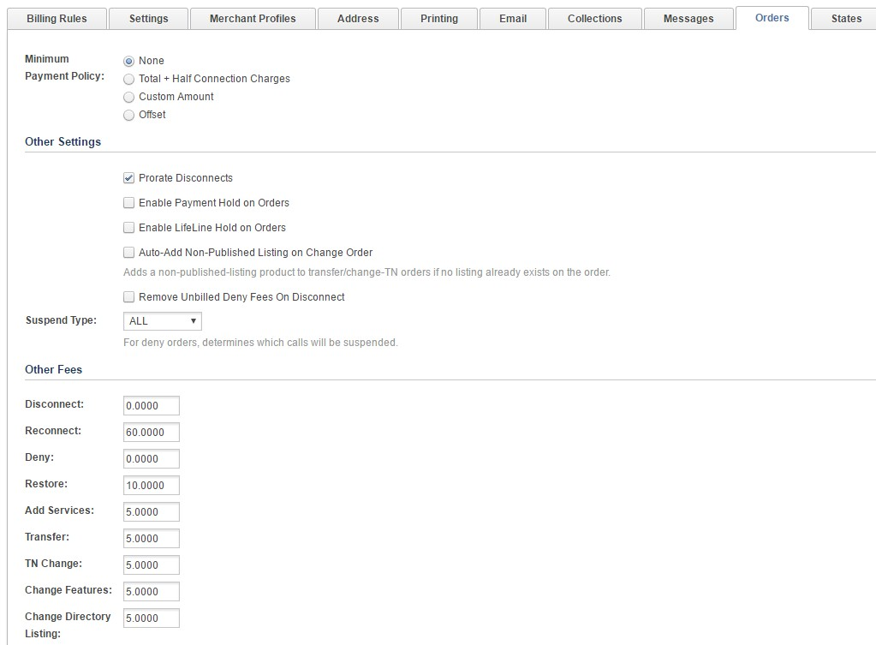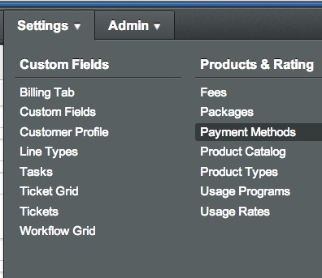Suspend Type - Allows you to choose which calls are suspended (Incoming, Outgoing, or All) if you choose to suspend calls on Deny orders

Other Fees - Fees related to the order process can be con×gured under this Tab. Leave at 0.00 where not applicable. These fees are automatically applied to the account when these options are selected on the Order.

States

The States tab can be ignored in most con×gurations. Ignore unless otherwise instructed by Rev.io.

Payment Methods/Merchant Accounts

Payment methods will be unique for each reseller and will need to be updated in the Bill Pro×le on the

Payment Methods are con×gurable in Rev.io. Payment Methods can be either a type that is used for posting and reporting only or a type that can be con×gured for electronic processing through a Merchant
Account. The list of Payment Methods used in Rev.io can contain both types.

1. To create the list of Payment Methods, go to Settings > Payment Methods.

2. Complete the following form for each Payment Method type and click Add.

Description – Name the payment method using a description. This description will appear in the drop down ×eld when selecting a payment.
Fee Desc – If using a fee for payment processing, this description will appear on the customer's statement.
Fee Type – Select from a Flat Rate fee or a Percent of the balance type fee.
Fee – Add the amount of the Øat fee or the percentage in this ×eld.
eCredit Card – If using a merchant account for processing credit card, select this checkbox. eCheck – If using a merchant account for processing electronic checks, select this checkbox. Requires Approval – Select if payment method requires approval.
Show in Signup – This checkbox will enable the payment method for use in the Signupgo workØow.
Show in Billcenter – This checkbox will enable the payment method for use in the Billcenter customer portal.
3. To edit or update a payment method, select the clipboard/pencil icon below. The payment method information will appear in the form above. Make the necessary changes and click Finish Editing. Once all changes are complete click Save before exiting the page.
4. The arrows below can be used to order the appearance of the methods in the drop down list.

5. The red "x" will delete the payment method.

Merchant Account Configuration

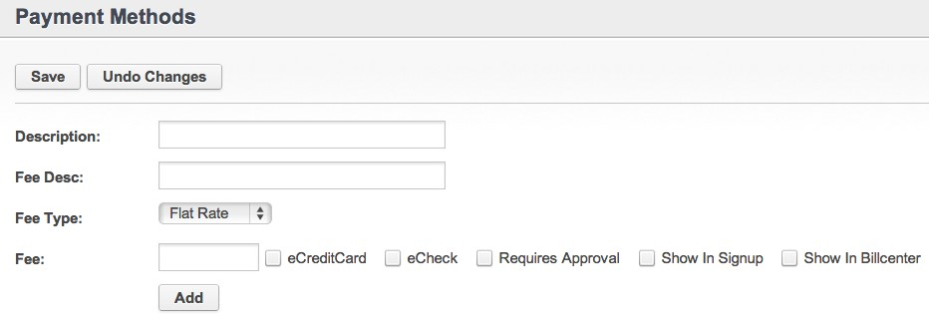Merchant Accounts must be con×gured by Rev.io. Please provide your project or client success manager with the API Login and Password/Transaction Key for the merchant account that needs to be con×gured. A list of supported providers can be found below.

Payment Gateway | e-Credit Card | e-ACH | Tokenization | Subscriptions
Authorize.NET | Yes | Yes | Yes | Yes
FideliPay | Yes | Yes | Yes | Yes
First Data | Yes | No | Yes | Yes
PayGate | Yes | Yes | Yes | Yes
USAePay | Yes | Yes | Yes - CC Only | Yes - CC Only

Email Templates

Overview

Email noti×cations to your customers, internal employees, & agents are customizable through the UI.

Creating a New Template

To create an email noti×cation template, go to Settings > Email Templates.

Under Settings > Email Templates, you will see 2 tabs:

Email Templates & Legacy Templates. This page is to set up the Email Templates tab. You can visit Legacy Email Templates page to see how those templates are con×gured and what they are used for. To add a new email noti×cation, click Add Template and complete the following ×elds.

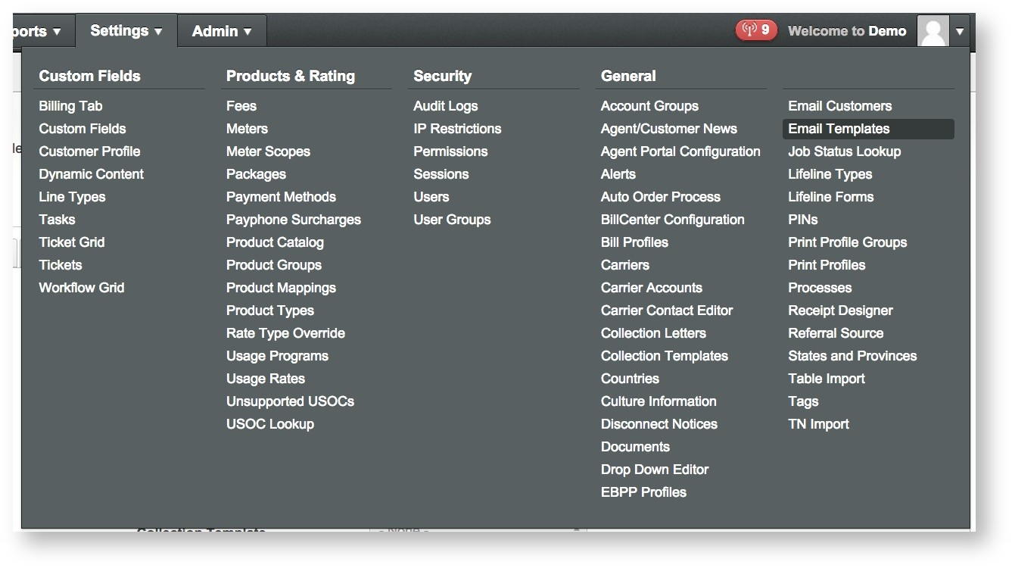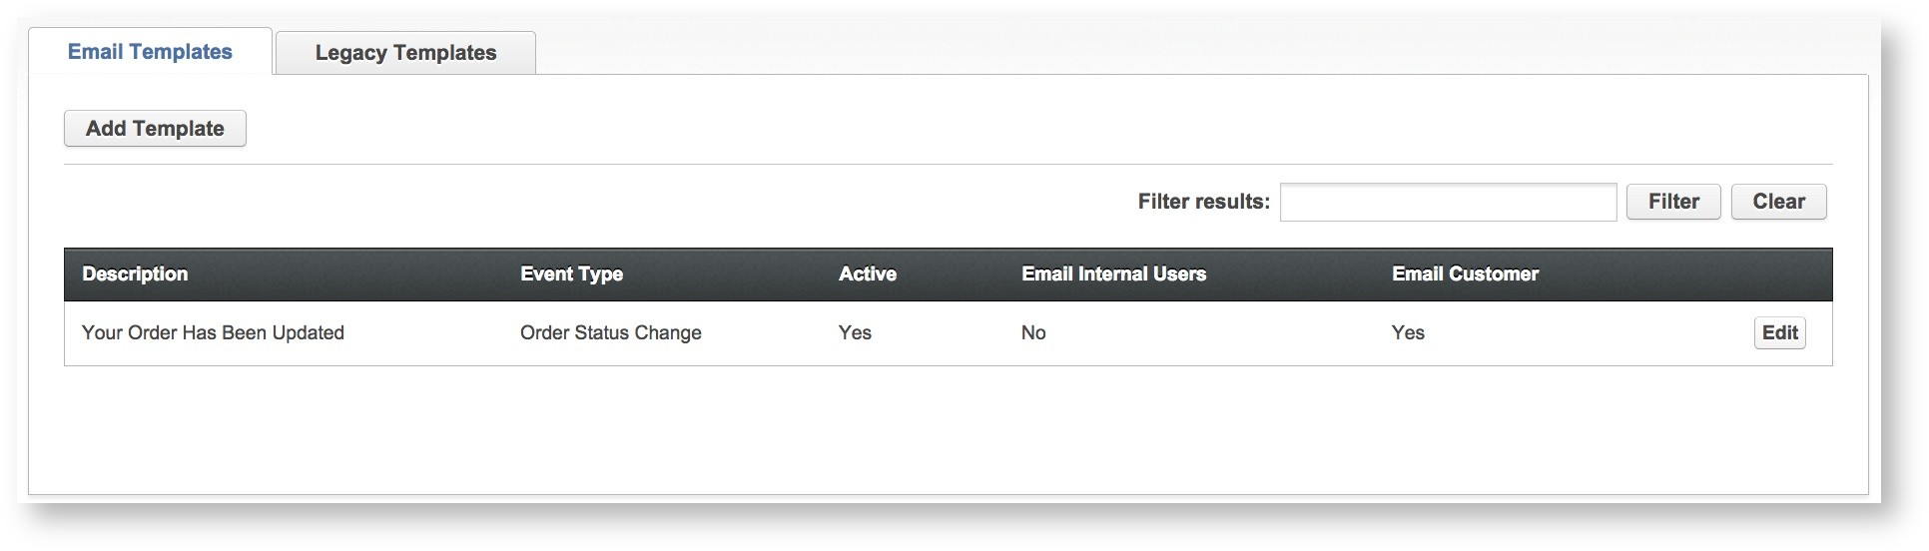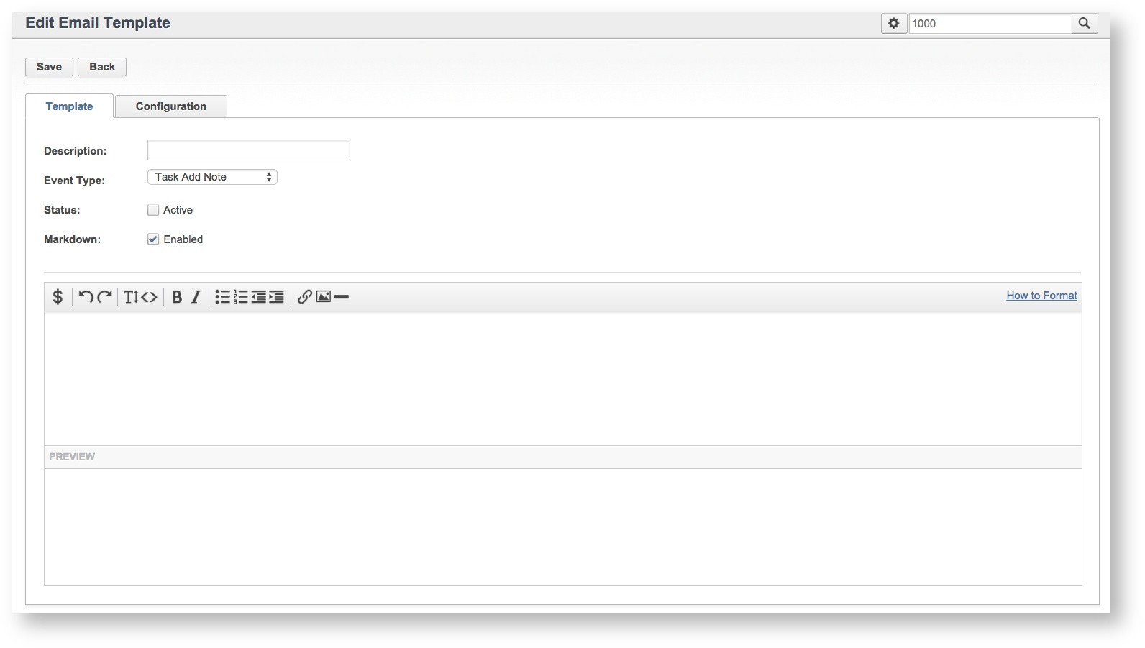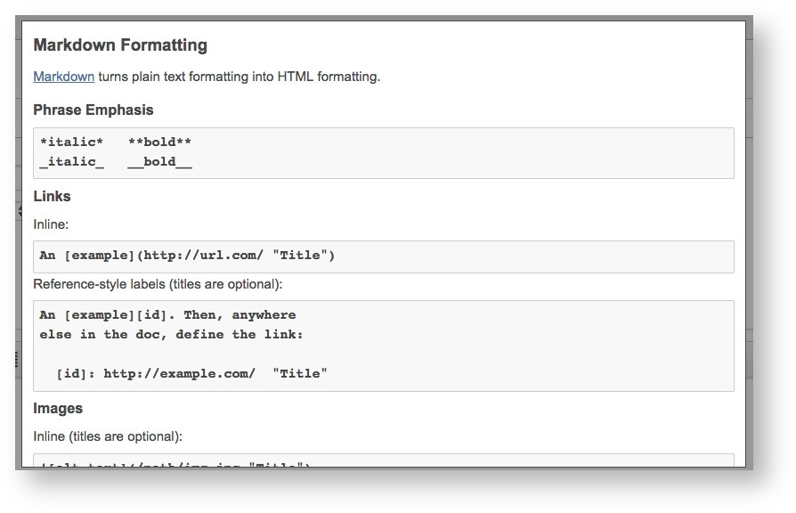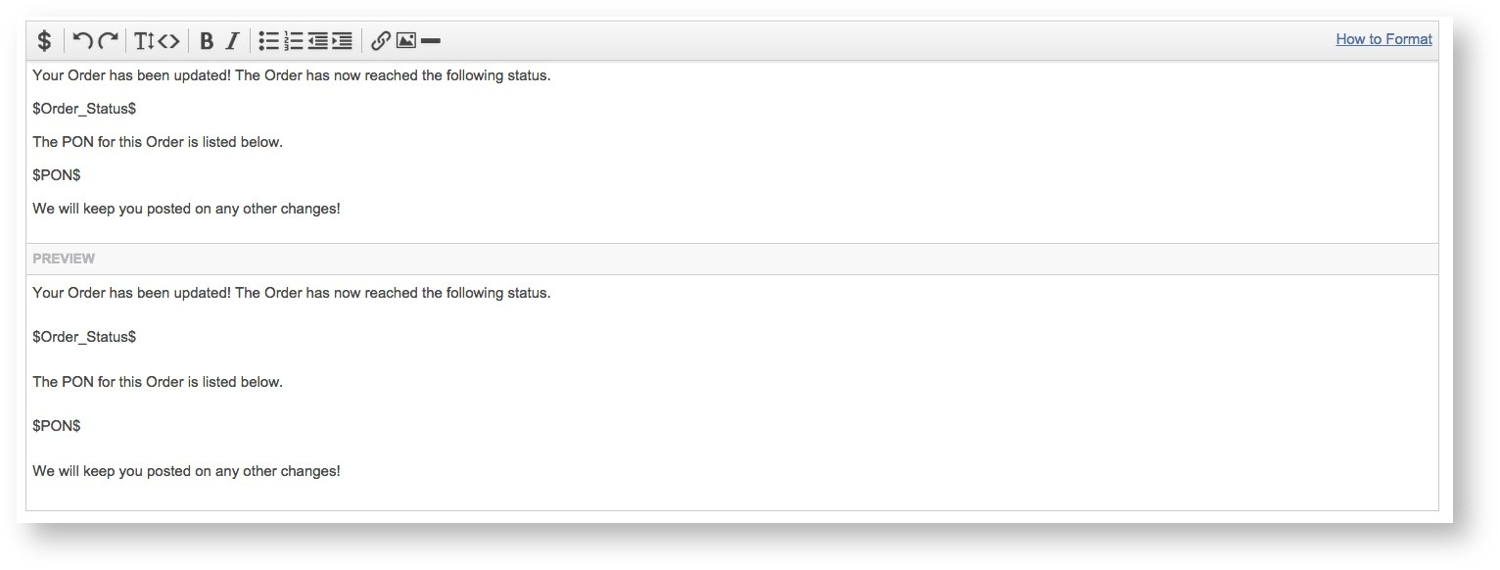Description – This ×eld names the template/noti×cation.
Event Type – This ×eld speci×es the activity that will trigger the noti×cation.
Status – This ×eld will turn the noti×cation on or off. Check the Active box to turn the noti×cation On or uncheck to turn off. Make sure you use this with caution!
Markdown – The ×eld enables Markdown support (the 2nd big text area). This ×rst text area can be used to write and format the body of the email, and the second text area uses Markdown to give you a preview of what your formatting will look like.
For instructions on formatting the email noti×cation, click the How to Format link and the right side of the email window. This link will open a window with formatting examples.

Other formatting tools can also be found in this window. Most options are similar to the formatting tools you might ×nd in any email management program. Tokens or Placeholder Codes can be found under the “$” button and used in the email to call data from the site database. Tokens will vary based on Event Type selection.

A formatted email noti×cation might look like this in the Edit and Preview panes.

Next click the Con×guration tab to complete the setup.

From Name & Email – This is the email address and name of the sender
CC & BCC – Email addresses that are CC'd and BCC'd on every email of this type that get sent. More than one address can be added by separating them with a semicolon.
Send To Internal Users – This will send an email to a default set of internal users associated depending on the type of email
Send To Customer – This will send an email to the customer associated with the task or order
Additional Emails – Any additional email addresses that will receive the email. Multiple email addresses can be used here as well.
Subject - This is an option for clients who would like to modify the subject line of the email being sent. If left blank, the subject will display the system generated subject line. This currently is not supported for clients using PoP3 for ticketing.
Filters – Rules can be added to templates so that the noti×cations only send for certain customers, orders, task types, ticket types and/or statuses. If no ×lters are speci×ed, the emails will always be sent when that email event is triggered.

Additional Notes

Filters are speci×c to they Event Type of the email template (de×ned on the Template Tab). Order noti×cation settings can be ×ltered by Bill Pro×le, Order Status and Order Type. Task noti×cation settings can only be ×ltered by Task Type.
Filters of the same type will work as an 'OR' use case (exclusive of one or more of the options). Filters of different types will work as an 'AND' use case (inclusive of all selected). All task emails are sent to the user that created the task, plus the assigned user and user group.
Order Status emails are sent to the user that created the order and the user assigned to the order

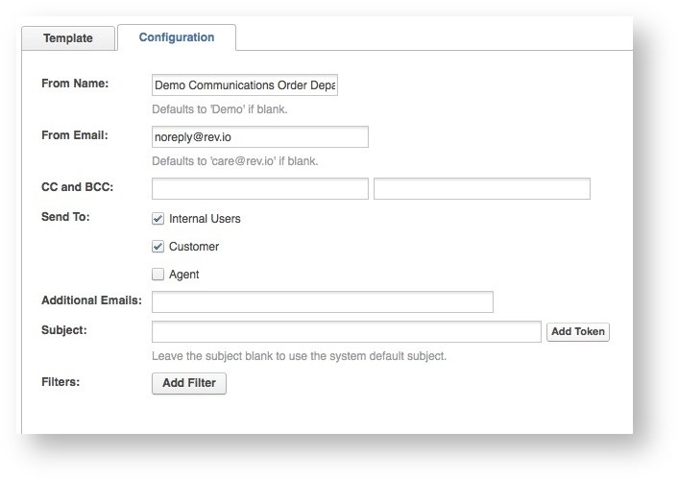The Email Templates are sent during certain events in Rev.io. The events are as follows:

Event | Internal/External  Communication | Description | Example
Auto Debit Success | External | An email will trigger when a customer was successfully Auto–Debited.
Auto Debit Failure | External | An email will trigger when a customer was unsuccessfully Auto–Debited.
Customer AutoDebit  Status Change | External | An email will trigger when a customer has either signed up or
Customer Created | Both | An email will trigger when a new customer pro×le has been created in Rev.io.
Customer Status  Change | Both | An email will trigger when the status on a customer's account changes.
Data Threshold Reached (Wireless only) | External | An email will trigger when the data threshold on a customer's account has been reached.
Order Created | Both | An email will trigger when an order is created on the customer account.
Order Status Change | Both | An email will trigger when an existing order's status has changed.
Password Reset | Both | An email will trigger when the user requests for a reset password link when logging into Rev.io. | $name_×rst$ $name_last$,  A password reset has been requested on your $Application$ account for user $login_name$.  Please click here: $password_reset_url$ to reset your password: The link to reset your password will expire within 12 hours.  If you did not make this request, please contact support immediately.
Payment Recieved | External | An email will trigger when a payment is submitted on a customer account (by an internal user in Rev.io OR by the customer in the portal). | Dear $Customer_Name$:  Thank you for your payment in the amount of $Amount$. It was submitted on $Created_Date$.  Best regards,  $Remit_Company_Name$
Request Created | Internal | An email will trigger when a request has been created.
Request Assigned | Internal | An email will trigger when a request has been assigned to an internal user.

Event | Internal/External  Communication | Description | Example
Request Approved | Internal | An email will trigger when a request has been approved.
Request Status  Change | Internal | An email will trigger when a request's status has been changed.
Task Created | Internal | An email will trigger when a task has been created. | $Assigned_User_Name$,  A new Task was created for customer **$Customer_ID$** -  $Customer_Name$ and assigned to you or a group to which you belong.  Please go to the [Task WorkØow] (https://demo.rev.io/Dashboard/TaskWorkØow.aspx) and see Task ID  $Task_ID$ to review.  Thanks!
Task Add Note | Internal | An email will trigger when a task has been created.
Task Completed | Both | An email will trigger when a task has been completed.
Task Reminder | Internal | An email will trigger when a reminder has been set up on a task.
Task Updated | Internal | An email will trigger when a task has been updated.
Ticket Created | Both | An email will trigger when a ticket has been created.
Ticket Updated | Both | An email will trigger when a ticket has been updated.
Top-up Product Added (Wireless only) | External | An email will trigger when a top-up product has been added to a customer's account.

Setup

For legacy clients, contact a client success manager to set up access to this feature, if it is not enabled already. New clients should have access to these new settings.

Agent Management

Agent pro×les must be set up in Rev.io and assigned to an account when the account is created. This creates the association between the account, agent and bill pro×le. The association of the Agent will happen automatically based on the User being assigned to an agent pro×le. The instructions below cover how to create a pro×le and to associate a user. You must associate the User with an Agent Pro×le before saving.

All agents and master agents must have a pro×le in Rev.io. The pro×le contains information such Parent Agent, Company Bill Pro×le, Company
Information, Users and Contact Information and Commission Plan if applicable.

Agent Profile

General

1. To create an Agent Pro×le, complete the following information.
Account Number – This ×eld can be used to assign a custom account number to the agent. Rev.io will generate an agent ID if left blank.
Type – This ×eld is a customizable list that can be used in reporting if desired.
Status – Used to activate or deactivate the agent.
Parent Agent – Select the parent agent if agent is a sub of a parent.
Commission Plan - Select the commission plan that should be associated with the agent.
Commission Trial Period - This ×eld is no longer in use.
Reseller Type - This ×eld is not required but information can be used for reporting purposes.
Reseller Customer ID - This ×eld is not required but information can be used for reporting purposes.
Tax ID - This ×eld is not required but information can be used for reporting purposes.
Language – Use this ×eld to specify the agent's language of choice.
ACH Frequency - This ×eld is no longer in use.
Company Bill Pro×le – Select a bill pro×le for the agent to designate only one bill pro×le for the agent's customers. This ×eld is required when using the Rev.io reseller model. This creates the partition for each brand.

On this page:

Agent Pro×le
General
Company Information
Primary Contact Information
Preferences
General Options
Packaging Filtering Options Commission Posting Options Override Custom Message on Customer Statement
Agent User Accounts
Agent Address

Company Information

1. Next complete the Company Information section as applicable.
Company Name – This ×eld can either house a company name or an agent's name. This is the identi×er that will appear in the agent drop down list on the account.
Company Email – Store the company email address in this ×eld. Company Phone – Store the company phone number in this ×eld. Company Fax – Store the company fax number in this ×eld.
Location Details – Store the location details of the company in this ×eld if applicable.
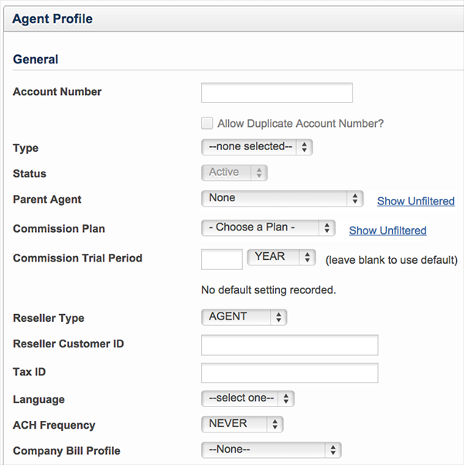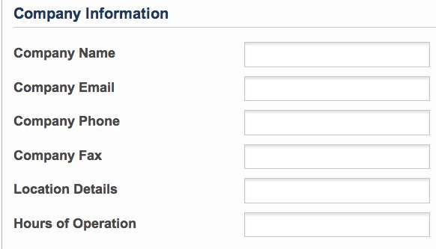Hours of Operations – Store the hours of operation in this ×eld if applicable.

Primary Contact Information

1. Complete the Primary Contact Information as applicable.
Type – Specify a contact type using the drop down list.
Name – This ×eld can be used to capture the agent's name.
Phone – This ×eld can be used to capture the agent's phone number. Mobile – This ×eld can be used to capture the agent's mobile number. Fax – This ×eld can be used to capture the agent's mobile number. Email – This ×eld can be used to capture the agent's mobile number.

Preferences

General Options

Leave General Options settings as is unless otherwise instructed by Rev.io.

Packaging Filtering Options

Leave General Options settings as is unless otherwise instructed by Rev.io.

Commission Posting Options Override

Leave General Options settings as is unless otherwise instructed by Rev.io.

Custom Message on Customer Statement

Leave General Options settings as is unless otherwise instructed by Rev.io.

Agent User Accounts

Agent Users associated with the pro×le will have access to all accounts assigned to the agent pro×le. If the agent pro×le is a parent then the Agent User will have access to all accounts at the parent level and below.
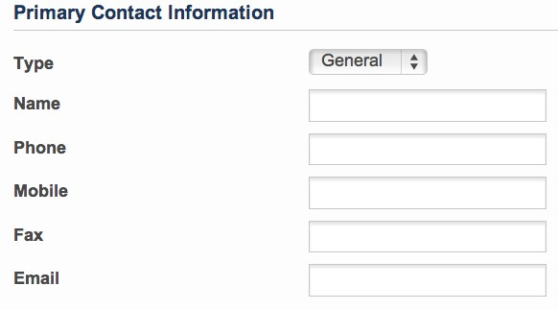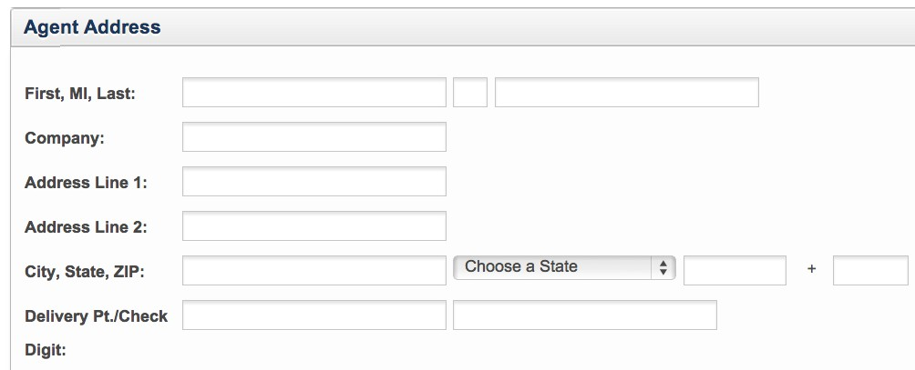1. To add an agent user account, select the user from the drop down list and click Add. Agents must be setup as users in order to appear in the user list.

Agent Address

1. Complete the following Agent Address details.
First, MI, Last – Use these ×elds to store the agent's full name.
Company – Use this ×eld to add the company name. Address Line 1 – Use this ×eld to add the company address. Address Line 2 – Use this ×eld to add the company address.
City, State, Zip – Use these ×elds to complete the company address.
Delivery Pt./Check Digit – Use these ×elds for additional address information.

2. Once all ×elds are complete, click Add to create the Agent Pro×le.

Permissions

A speci×c role must be con×gured for a Reseller. This role is a variation of the Agent role that comes with Rev.io and has been con×gured for you. This role is called Reseller Agent. You will need to copy and put the reseller name in front of Reseller Agent so you can identify which permission belongs to each reseller.

Unable to render {include}
The included page could not be found.

Billcenter.net Setup

Billcenters are con×gured using the instructions below and must be associated with a Bill Pro×le on the Con×guration tab of the form.

Billcenter.net (Customer Portal) is con×gured and managed from Rev.io. Each Rev.io instance can have multiple Billcenter.net con×gurations.

1. Go to Settings > Billcenter Con×guration to begin.
2. Click Create New.

Settings

1. Under the Settings tab, enter new HTML color codes to update the colors used in the Navigation, Page Title and Hyperlinks.

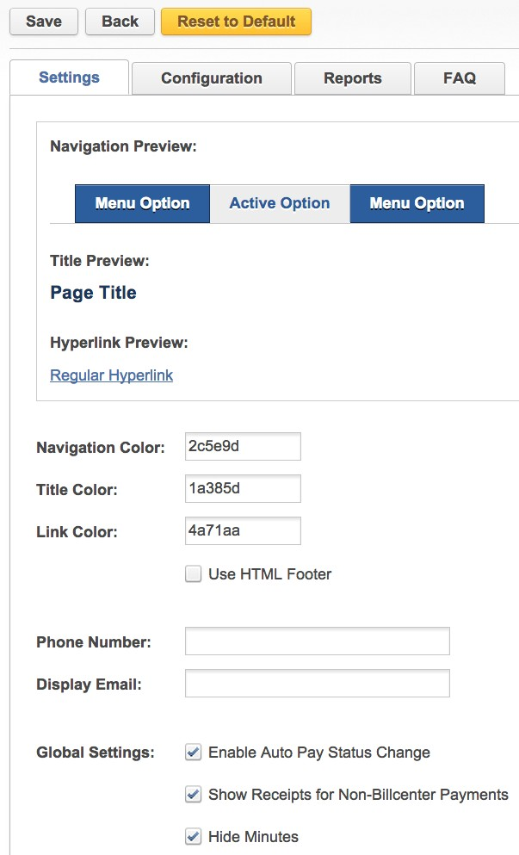 Color codes can be found at colorpicker.com.

2. Select the Checkbox for Use HTML Footer to add this option to the page.
3. Under the Global Settings options, the following settings can be enabled or disabled.

Enable Auto Pay Status Change – This will allow the end user to modify this option in the BillCenter.net portal.
Show Receipts for Non-Billcenter Payments – This option will allow for all payment receipts to show in BillCenter regardless of how the payment was captured.
Hide Minutes – This option must be selected if the end-user is not a wireless customer.

Configuration

Additional settings are found under the Con×guration tab.

Bill Pro×le – Allows the user to designate a speci×c bill pro×le for the con×guration.
Hostname – This ×eld should be populated with the Rev.io speci×ed URL for accessing the site.
Main Title – This ×eld controls the main title of this BillCenter con×guration.
Bill Restriction – Restrict bill receipt method options using this setting.
Allow Disenroll - When not checked, removes the "None" option from the Bill Delivery radio list on BillCenter, under Settings, so only Email and Print are left. (e.g. by default, customers cannot change their bill delivery method to None and end up not receiving a bill). If you want to disable the ability for people to change their statement delivery methods, you need to remove the
permission BILLCENTER_MANAGE_BILL_NOTIFICATIONS from their User's permissions. It is under Rev.io > Billcenter Settings, and it's called Manage Noti×cation Options
Website URL – Populate this ×eld to add a URL to the sign on page of Billcenter.
Email Ticket Noti×cations To – Use this ×eld to setup an email address to receive ticket noti×cations when customers create a ticket in BillCenter.net.
Email Payment Noti×cations To – Use this ×eld to setup an email address to receive payment noti×cations when a customer makes a payment in BillCenter.net
Company Image – This is the location of the logo image used on this con×guration of BillCenter.net. Most likely Rev.io will manage the logo ×le and this ×eld will not require any changes.
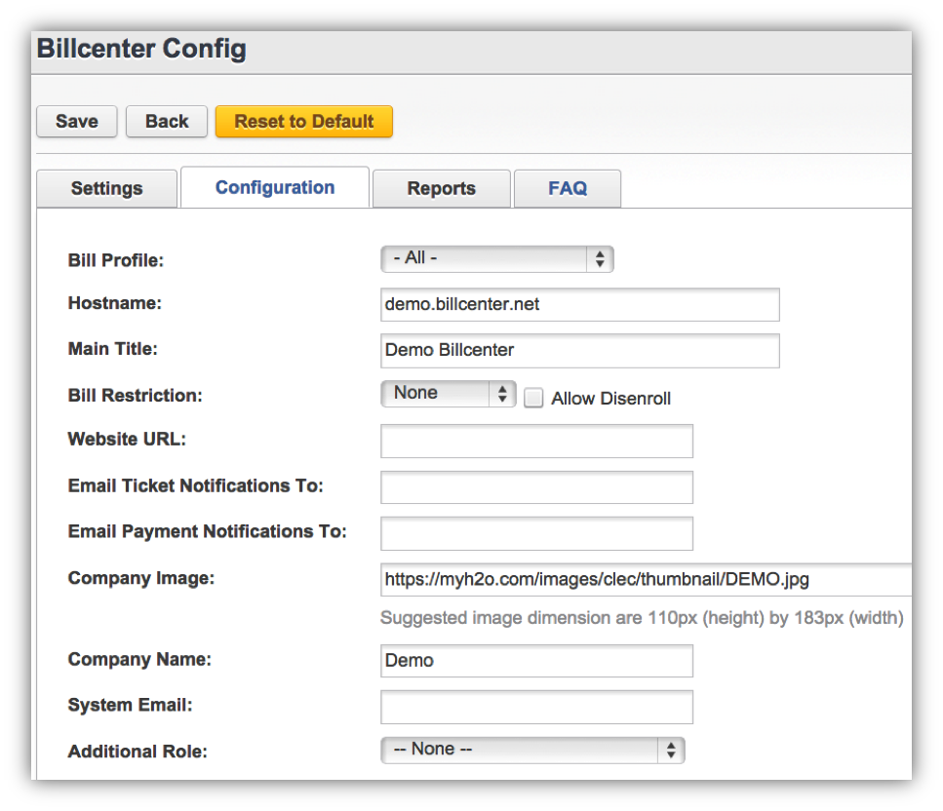System Email – Populate this ×eld with a system email that a user could use as a point of contact.
Additional Role – Select a user role for Billcenter from this drop down list.

Reports

The functionality on the Reports tab allows the user to customize a list of report visible to the customer in this con×guration of BillCenter.net.
To make a report available in BillCenter.net, double click the report in the Available Reports column and the report will move to the Selected Reports column.

FAQ

Use the FAQ tab to build Questions and Answers for the customer that will be displayed on the Help tab.

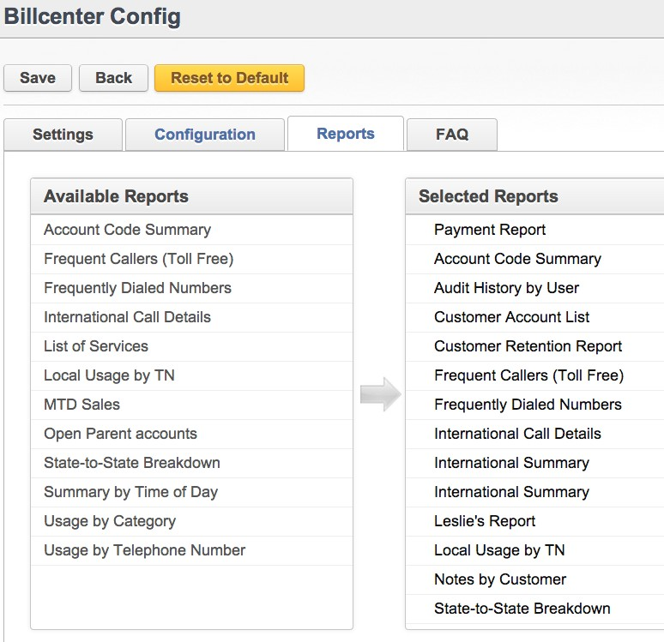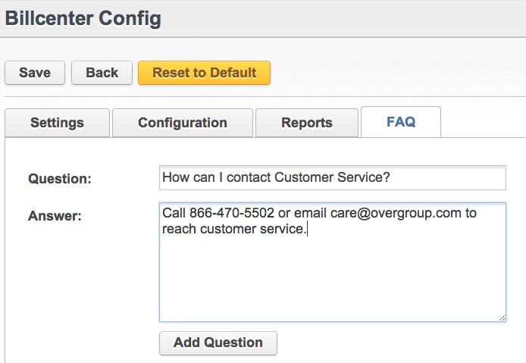1. To build a question, type the question in the text box labeled Question. Type the answer in the text area labeled Answer.
2. Click Add Questions.
3. Questions can be edited or reordered in the table located at the bottom of the screen.

Products & Packages

Products can be con×gured using the instructions below. Products must be associated with a Bill Pro×le under the Restrictions tab to associate them with a particular reseller. You can also create a generic product catalog and share with all resellers.
Packages can also be con×gured using the instructions below. Packages must be associated with a Bill Pro×le and/or Agent to associate them with a particular resellers. Bill Pro×les are found on the
Restrictions tab and Agents are associated on the Agents tab.

Creating Products

Products that are applied to the customer’s account are con×gured in the Product Catalog. To create a product, complete the following steps.

1. Go to the Settings tab > Product Catalog.

2. Click Add New Product.

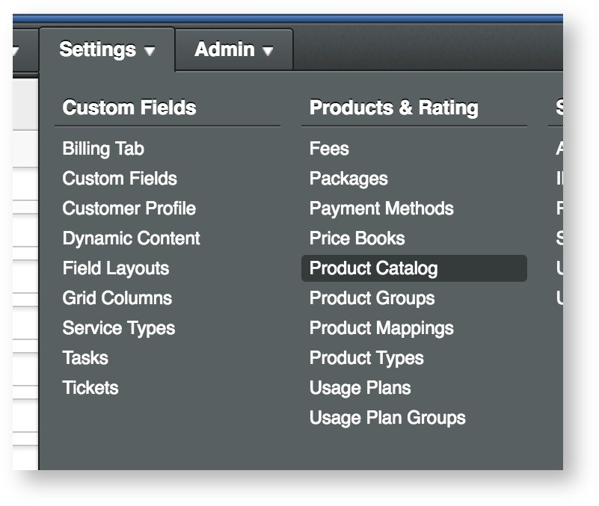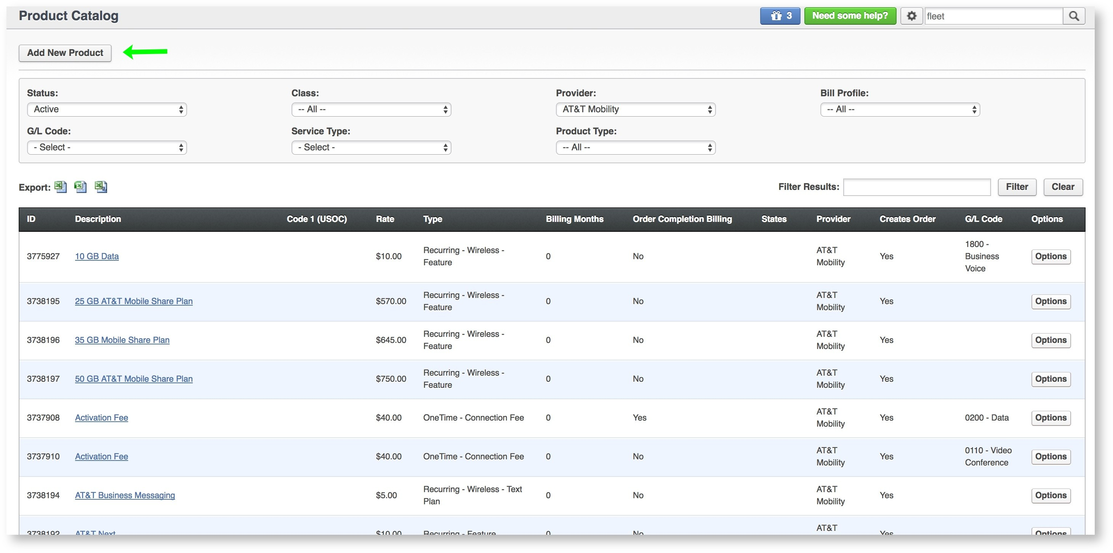3. Complete the General information tab as applicable. An example and de×nitions are below.

a. Description – This ×eld contains the description of the product that will display on the bill. i. Apply Description to Active Packages with this product -
ii. Apply Description to Active Products -
b. Type – This ×eld determines whether the product is one-time or recurring. These options are often associated with the tax classi×cations (unless the tax class is being overridden through the next
×eld).
c. Tax Class - Tax classi×cations can be con×gured on the product (instead of defaulting to the product type's tax class) by selecting Override and then the desired tax class. d. Provider – This ×eld will associate the product with a speci×c provider.
e. Code 1 (USOC) – (Optional) This ×eld supports provisioning codes for electronic ordering and provisioning with providers. This will be different for all electronic provisioning integrations. i. In wireline provisioning, this ×eld designates a speci×c product.
ii. In wireless provisioning, this ×eld may contain information about the account to provision with or the amount and expiration of the product.
f. Code 2 (FID) – (Optional)This ×eld is also used for ordering and provisioning with providers. This will be different for all electronic provisioning integrations. i. In wireline provisioning, this ×eld is rarely used.
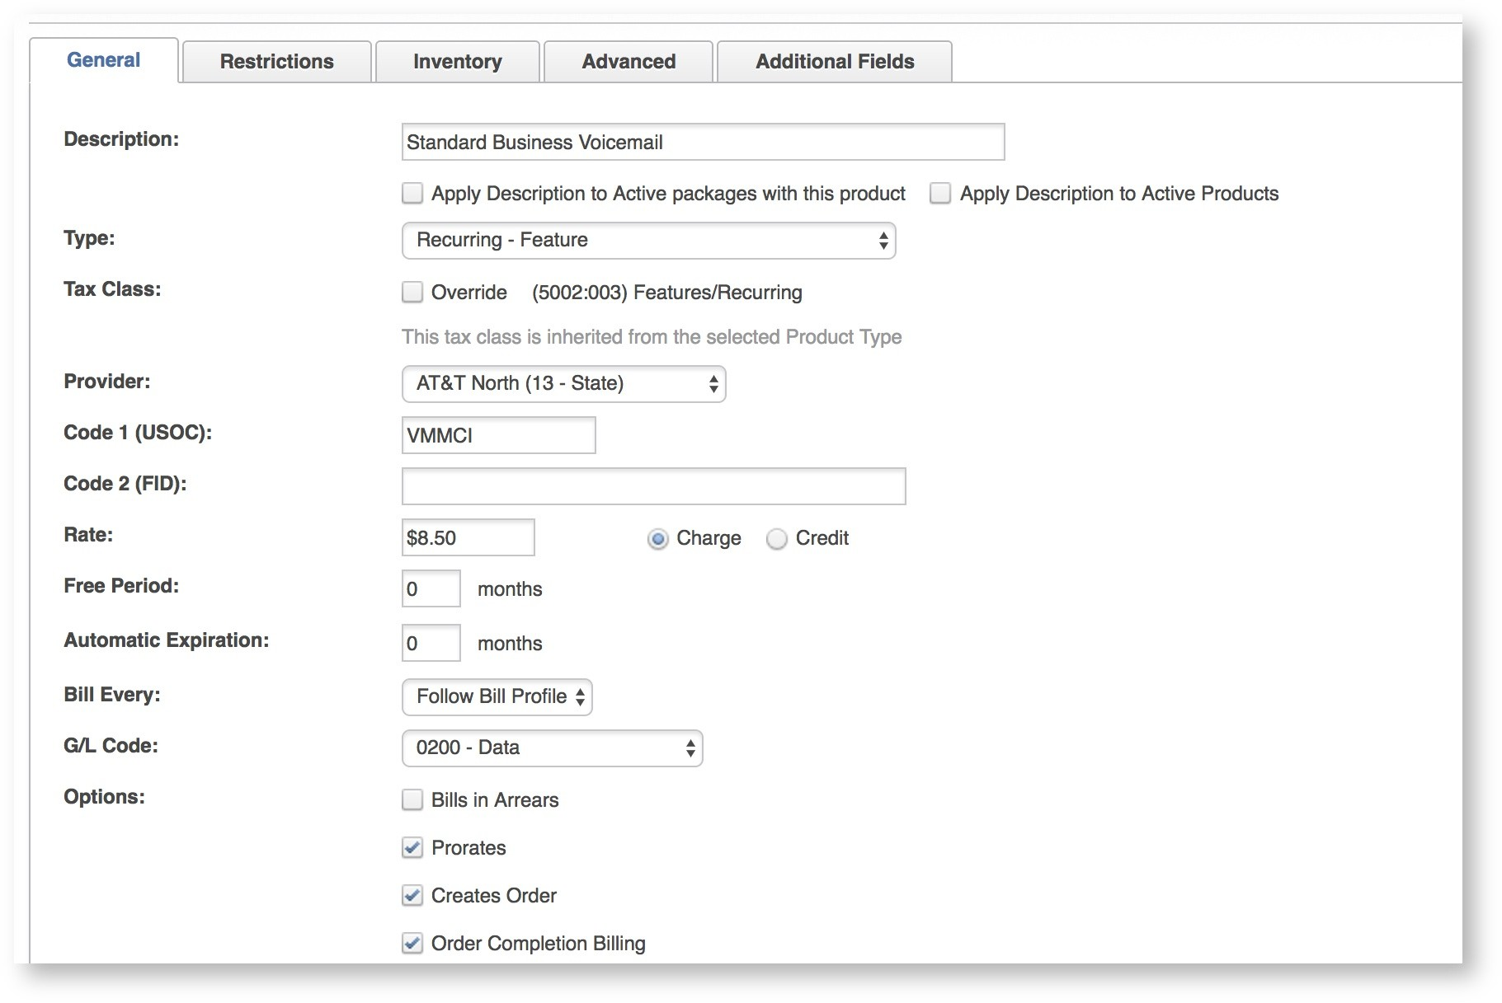ii. In wireless provisioning, this ×eld may contain information about the account to provision with or the amount and expiration of the product. g. Rate – Populate the rate that will be passed on to the customer and whether it will be a credit or debit product.
h. Free Period – This ×eld is used to override the rate of the product for a designated number of months. i. Automatic Expiration – This ×eld is used to set an expiration for the product.
j. Billing Months - Bill a recurring product monthly by selecting Standard or select an options for Quarterly, Semiannually or Annually billing. The Rate ×eld is always monthly though so all rates need to be divided by how often they are billed.
k. G/L Code – This ×eld can be used to create a customizable product category list for reporting purposes. This list is con×gured under Settings > Drop Down Editor. l. Options
i. Bill in Arrears – Select this option if this product should always bill in arrears. ii. Prorate – Select this option if the product should prorate.
iii. Creates Order – Select this option if the product should be on an order.
iv. Order Completion Billing – Select this option if the product's MRC should wait to post to the account until the order completes.

**Best Practices for Options above**
Prorate: Typically for one-time charges, proration is off. For recurring charges, it is on (but can be variable for recurring).
Creates order & Order completion billing:
Typically, for recurring charges, Creates Order is on and Order Completion Billing is on.
For one time charges, Creates Order is also on, but Order Completion Billing is off. The reason for this is to allow the charges to post to the account immediately. Often, with one time install charges, fees, equipment, etc., you want the ability to bill it before the recurring services are ready to bill. If you want your one time charges to not post early, (and just post at the same time as the recurring charges), leave order completion billing on.

Complete the Restrictions tab as applicable.

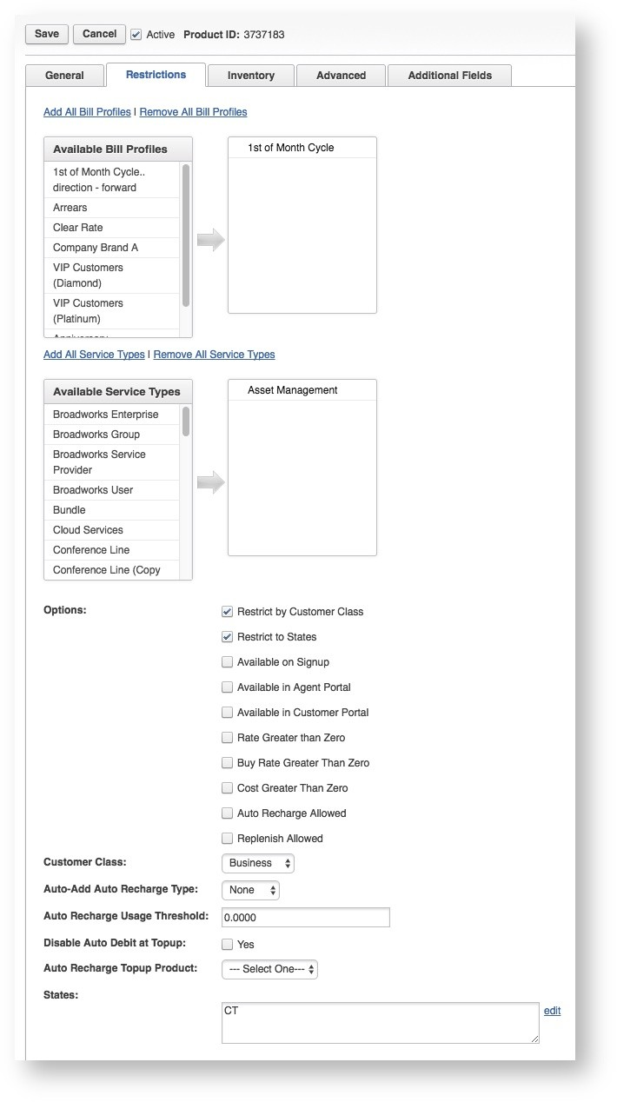1. Available Bill Pro×les – Select applicable Bill Pro×les if the product should be restricted by Bill Pro×les.
2. Available Service Types – Select applicable Line Types if the product should be restricted to a particular line type(s).
3. Restrict by Customer Class – Select this option if the product should be restricted to either business only or residential only customers.
4. Restrict to States – Select this option if the product should be restricted to a state or certain states.
5. Available on Signup – This option will display the product on the SignupGo application.
6. Available in Agent Portal - Option not available today.
7. Available in Customer Portal – Option not available today.
8. Rate Greater than Zero - Added for commission support.
9. Buy Rate Greater than Zero - Added for commission support.
10. Cost Greater Than Zero - Added for commission support.
11. Auto Recharge Allowed - Controls whether or not auto recharge is allowed for this product.
12. Replenish Allowed – This option will enable the product to be available for use as a wireless replenishment.
13. Customer Class – If using the Restrict by Customer Class option, select the class here. **This will default to a value, but will only take affect IF the "Restrict by customer class" checkbox above checked!
14. *Auto Add Auto Recharge Type – This ×eld is used to designate the Auto Recharge Type. Options are None, Monthly, and Usage.
15. *Auto Recharge Usage Threshold – This option is used to set a threshold for auto recharge on wireless accounts.
16. *Disable Auto Debit at Topup - This feature will disable Auto Debit when a product tops up.
17. *Auto Recharge Topup Product - Select a topup product from the catalog, here. This will be the one-time product that you use for data overages.
18. States - Only shows up when "Restrict to States" is selected. Allows you to restrict products by states, comma separated.

* = Wireless Features

1. The Inventory tab contains all available inventory available in Rev.io. To relate a product to an inventory item, select the item(s) from this tab.

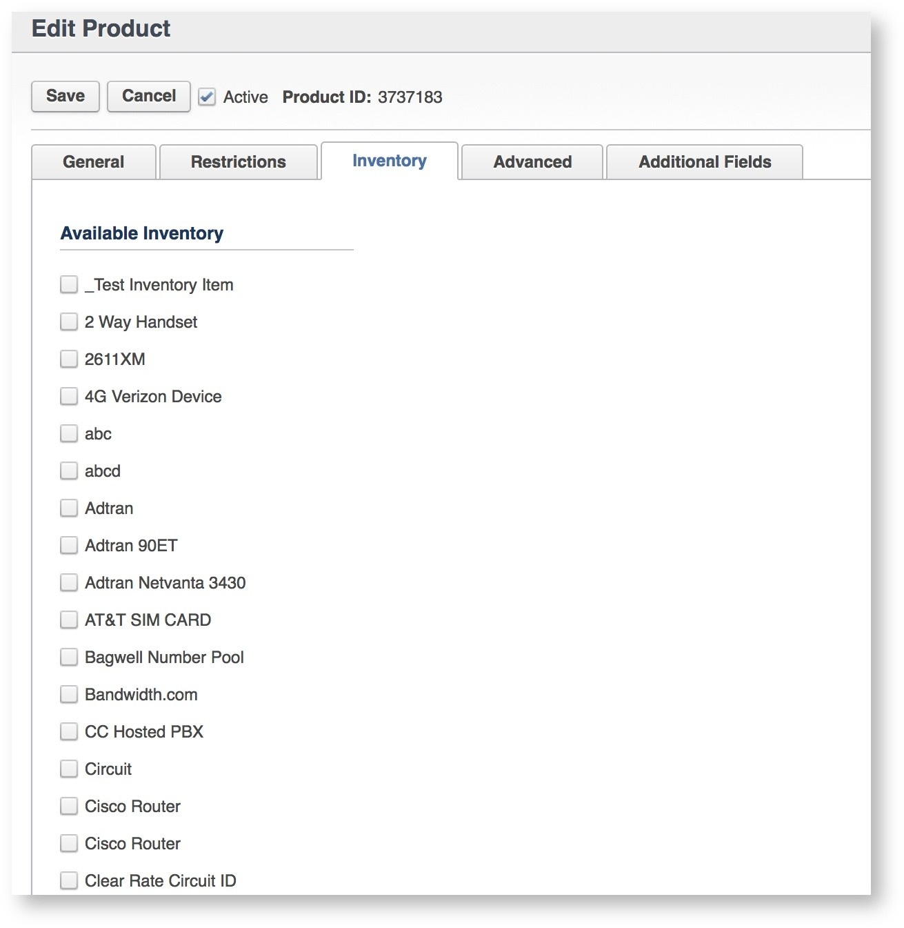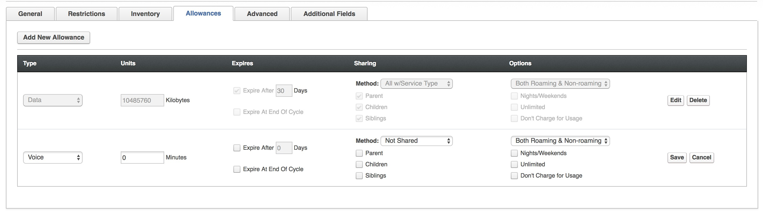2. The Allowances tab only appears when a Recurring - Wireless Product Type is selected and the Provider has Management of Service Allowance selected as a Requirement. The Allowances tab controls how the product will behave, how much of the product is allowed and when it expires.

a. Type - Options for Type Allowances include - Voice, SMS, MMS, Data and Sponsored Data.
b. Units - Units will toggle based on type selection. One important note is that all Data must be converted to Kilobytes. c. Expires - A product can be set to expire in a designated number of days or at the end of a customer's cycle.
d. Sharing - Units can be shared with the Parent, Children and Siblings. Multiple options can be selected. The Method of Sharing may also vary. Those options are Not Share, All Services, All w/Same Package, All w/Service Type, or All w/This Product.
e. Options - Options include Nights/Weekends, Unlimited and Don't Charge for Usage. Also included is the ability to select from Both Roaming & Non-roaming, Do Not Apply to Roaming and Only
Apply to Roaming.

3. The Advanced tab contains several other options that require complimenting functionality in Rev.io. Commonly used ×elds are noted below. For all other ×elds, contact an account manager to see if the ×eld can be used.

a. Wholesale Description - Additional description used for reporting.
b. Buy Rate - A ×eld to set the buy rate for an agent. Used for reporting. c. Cost - A ×eld to track the cost of the product. Used for reporting.
d. Commissionable - If enabled, the product can be set up for residual or monthly commissions.
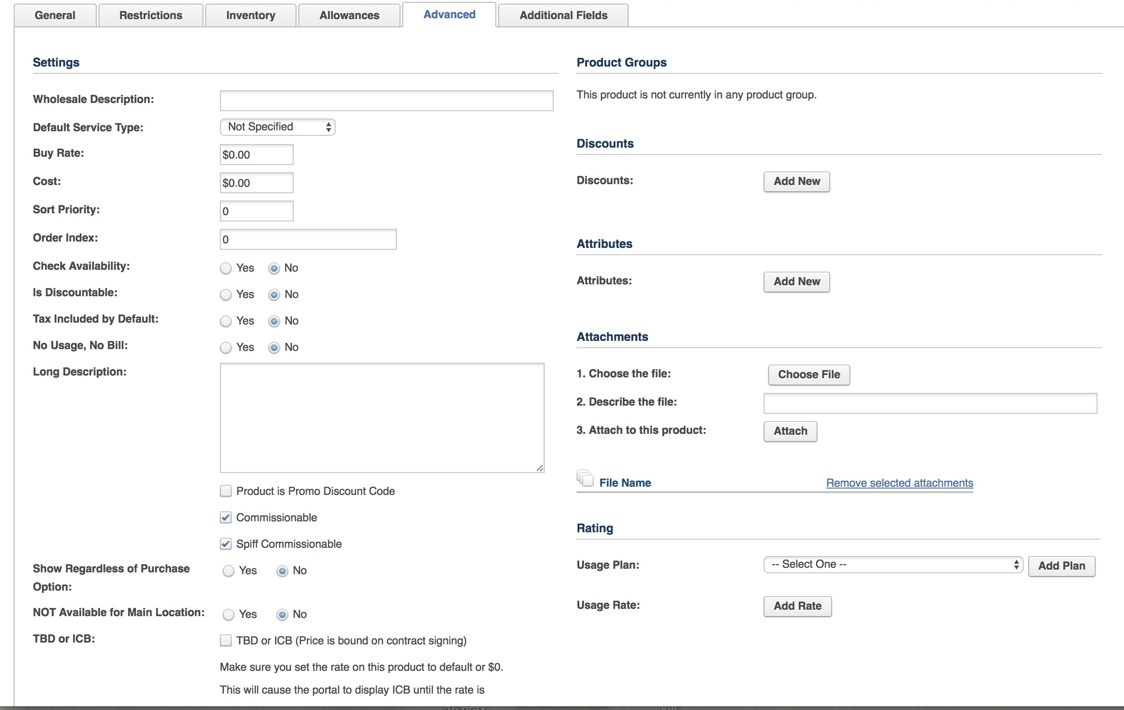e. Spiff Commissionable - If enabled, the product can be set up for spiffs or one time commissions.
4. The Additional Fields tab is used for storing any custom ×elds added on the product.
5. Save to add or update the product.

Deactivating Products

1. To deactivate a product go to Settings > Product Catalog.
2. Click Edit on the Product that needs to be deactivated.
3. Deselect the Active? Checkbox to deactivate the product.

Creating Packages

1. Go to Settings tab > Packages.
2. Click New.

3. Enter in the Package's General Information. The required ×elds are highlighted below.

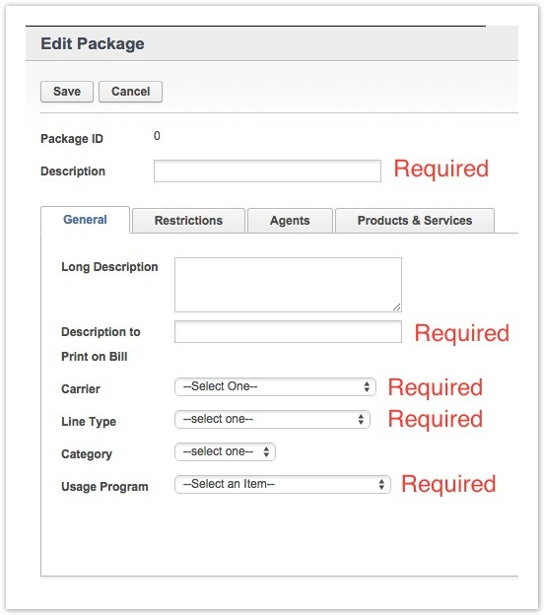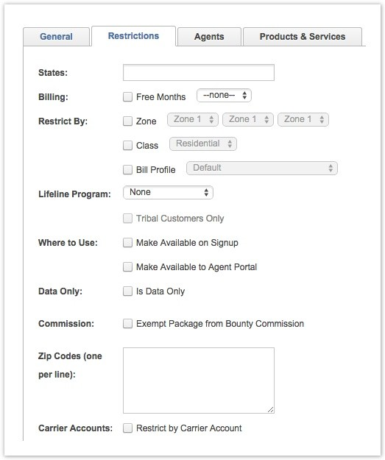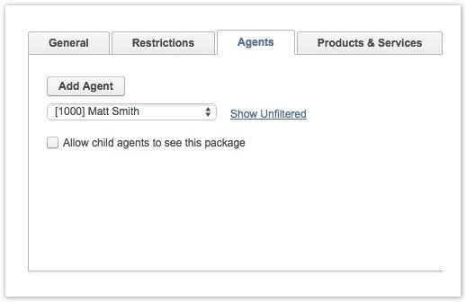4. The Restrictions tab contains several optional ×elds that are used to restrict the use of the Package. None of these ×elds are required.

5. The next tab is the Agents tab. Packages can be restricted to agents. No ×elds on this tab are required.

6. On the Product & Services tab, click Add a Product to choose product(s) from the product catalog to be added to the package.

7. The following descriptions de×ne each ×eld and whether or not it is required. a. ID - Rev.io populated ×eld.
b. Description - This description providers over from the Product Catalog. c. Provider - Taken from the provider set in the Product Catalog.
d. Code 1 (USOC) - Taken from the provider set in the Product Catalog. e. Code 2 (FID) - Taken from the provider set in the Product Catalog.
f. Rate - Taken from the provider set in the Product Catalog.
g. Rate Type - Taken from the provider set in the Product Catalog. h. Quantity - Adjust speci×c to the Package.
i. Group - This checkbox is enabled by default to group all Products under the Package name. **One-time charges will NOT group under the package name since they show in a separate area on the bill.
j. Tax Incl - This checkbox is off by default. This option will include the tax in the rate speci×ed in the Rate ×eld. k. Itemize - Selecting this ×eld will allow for the individual product to display on the bill under the Package.
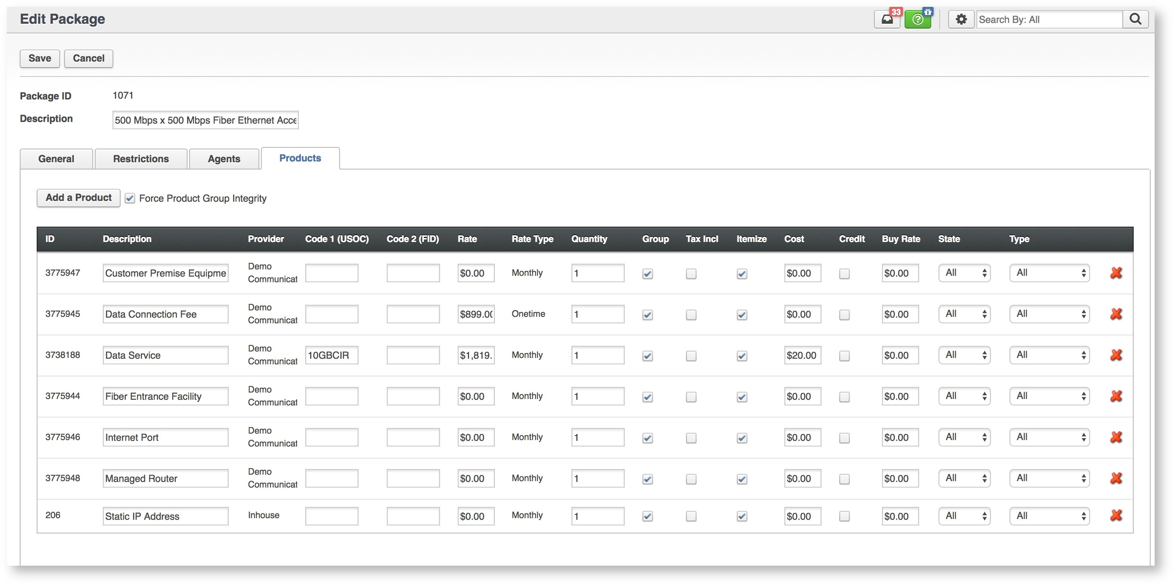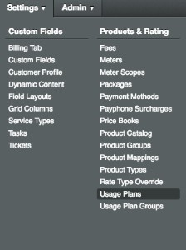l. Cost - This ×eld is used to store the Cost of a Product.
m. Credit - This ×eld can change a debit in to a credit product.
n. Buy Rate - This ×eld is used to store the Buy Rate of a Product. Buy Rates are used to calculate margins or commissions for Agents or Resellers. o. State - This option will only apply this product when the State selected matches the Service Address of the account.
p. Type - This option will only apply this product when the Type matches the Order on the account. q. Remove products by selecting the Red "X".
8. Click Save to create the package.

Usage Rates and Usage Plan groups

Summary

Rev.io offers several ways to create usage plans and apply them for call rating. Usage Plans can be added manually using a form in the UI. This is useful if only a few call type/rates will be included in the plan. The other option is to import the rates using a template ×le. This option is great for importing international rate decks or updating a large ×le of rates. The information below covers all of those options including how to upload different versions of rate decks into the same plan and set the effective dates for when those should begin. Usage Plans are grouped in to a Usage Plan and assigned to the line/service, used individually in the Special Rates section on the customer pro×le, or added at a product level in the Product Catalog.

Creating a New Usage Plan Manually

1. Usage Plans are the rates that apply to the individual call record based on call type. To create a new Usage Plan, go to Settings > Usage Plans and click Add.

2. Add a description and click Save to access the remaining ×elds on this page.

3. Complete the ×elds in the Usage Plans on this Plan section to add a new rate. The following ×elds are required:
a. Description - Use a name that will describe the content in the rate.
b. Rate or Surcharge - Two separate ×elds that can be used independently to de×ne the rate per call or a Øat surcharge. Both ×elds can be used on a line item if desired.
c. Country/Area/State - Typically used to specify International Dialing Codes (Country), Telephone City Dialing Codes (Area) or State or Province Abbreviations (State) for calls outside of the U.S. Depending on how calls are rated for this plan at least one of these ×elds may be required but not all.
d. Product Type - This ×eld is used to tell Rev.io what type of call this rate will apply. Specifying this ×eld requires some knowledge about Product Types in Rev.io and how calls are assigned a call type. A full list of usage Product Types can be found under Settings > Product Types. Sort by the Description header in this table to see all Usage call types and tax classes associated with them.
e. Initial/Increment - Speci×es the initial billing minimum call length and how it will incrementally bill after that. Here's an example of each - 30/6: This indicates that there is a minimum billing length of 30 seconds followed by 6 second increments. For example, a 15 second call will be billed at 30 seconds because it is within the 30 second minimum. A 43 second call will be billed at 48 seconds. A helpful way to view this would be 30+6+6+6.
f. Call Direction - Speci×es the direction of the call. This field accepts BOTH, INBOUND, and OUTBOUND as the call direction
All other ×elds can be used as needed to create more speci×c rating rules. Please discuss use of these ×elds with a project or account manager to make sure they are compatible with your CDR
importer.
4. A Usage Plan can have one or many line items. Press the Save button once all rates have been added to the table on this page.

 A Usage Plan set to capture and rate domestic calls at a certain rate might look like the example below. This Usage Plan contains 4 entries; interstate, intralata, intrastate and local. Each rate is set to 0.00 indicating that these calls will be rated but the customer will not incur a charge. This Usage Plan can be placed at the Product or in Special Rates on the Customer Pro×le. It may be combined with other Usage Plans to create a Usage Plan Group and used on a Line/Service level.

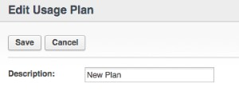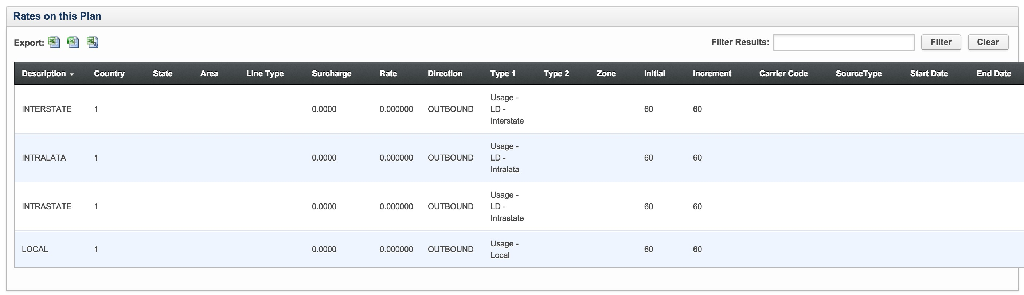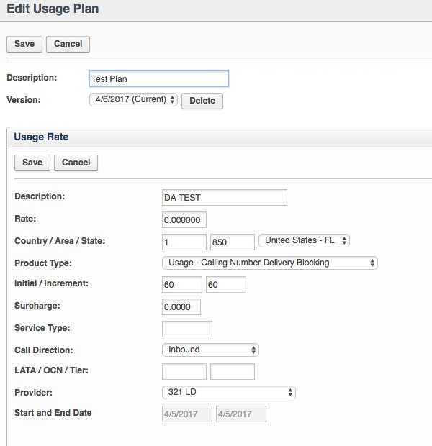Editing an Existing Usage Plan Manually

1. If editing an existing Plan, go to Settings > Usage Plans.
2. Click Options > Edit on the Usage Plan that requires editing.
3. Click Edit next to the Usage Rate that requires editing.
4. Scroll to the bottom of the page to the rate table and click Edit on the selected rate from the table at the bottom of the page that requires the edit. The link is in the last column on the right side of the table for each line item. Update the information in the Rate section of the screen and click Save.

5. Alternatively, the rate from can be completed and saved to add a brand new rate to the existing plan.

Importing a New Usage Plan

1. To import a new .csv ×le of rates, go to Settings > Usage Plans.
2. Click Add New.
3. Add a Description for the Plan and click Save.
4. Select the Import button

5. The importer page, when adding a new usage rate, will show Create New Version as the Usage Plan Version.

5.b If the Usage Plan Version drop-down is blank (doesn't display: "Create new Version") then the Usage Plan Rate Versioning module will need to be activated.
To do so go to Admin > Settings > Enabled_Modules > Select "Plan Rate Versioning" in the drop down > click Add > click Save > log in/out of your Rev.io session to see the change.

6. Set the Effective Date for when the rates will begin. The Effective Date allows for uploading rate decks for future use and also allows for version management of Usage Plans. A usage rate may also be added with a date from the past. All usage plans in Rev.io prior to the release of this feature (release date: 03/18/2016), are considered initial versions and remain in effect until a new version is uploaded to replace them.

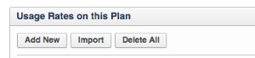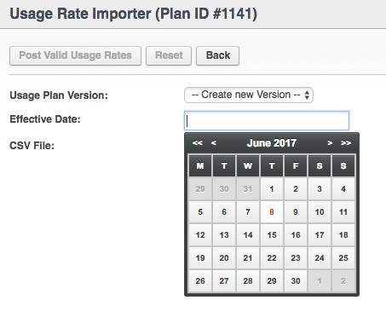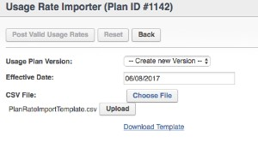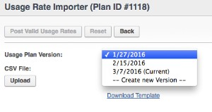 If backdating a ×le, any records that were not previously rated and are fairly recent calls (last 30 days or so) will be automatically reviewed each night. Files that were previously rated will require rerating. The Rev.io Client Success Manager will need to assist with this.

7. Choose a pre-formatted ×le or select Download Template for the ×le format. Select the Upload button once the ×le is ready for import. Files that are not in the appropriate format will fail to upload.
See the section titled Formatting a File Using the PlanRateImportTemplate for tips.

8. Select Post Valid Rates to complete this process. If this is a new Usage plan, it is now ready for use based on the Effective Date set for the ×le. This Usage Plan can be used with a Usage Plan Group or it can be added at an account level under the Special Rates link.

Importing a New Plan Version or Appending to a Plan Version on an Existing Usage Plan

1. To import a New Plan Version to an existing Rate, go to Settings > Usage Plans.
2. Click Options > Edit on the Usage Plan that requires editing.
3. Click Edit next to the Usage Rate that requires editing.
4. Select the Import button.
5. Select a plan version to append the rates to or click Create New Version to add a new ×le with a new effective date.

6. If creating a new version, specify the Effective Date.

7. Once the Effective Date has been speci×ed, select Choose File and Upload.

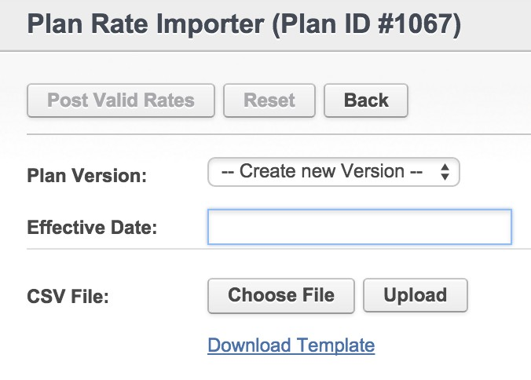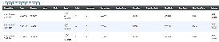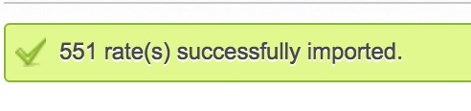8. Once the ×le uploads a table of rates will appear at the bottom of the screen.

9. Select Post Valid Rates and OK to con×rm and complete the process.
10. A message will appear at the top of the screen to con×rm success.

11. Start and End dates will be set on each table of rates depending on the effective dates. No end date will be speci×ed on the ×le with the latest effective date until a new ×le is added with an effective date beyond the start of the previous ×le.

Formatting a File Using the Usage Rate Template

The Usage Rate template contains the ×elds in the table below. Each line item represents a rate for a speci×c type of call.

Field  Name | Description | Required
Description | This is a description that de×nes the type of call this rate will apply. Some examples of descriptions used in Rev.io today are a country and city name like Alberta-Canada, a type of call like Outbound Interstate Traf×c or an NPA NXX like 770-415. | Yes
Type 1 | This ×eld is used to tell Rev.io what type of call this rate will apply to. These types must match the Product Type exactly. Usage - LD - 800 - Intrastate or Usage - LD - International are examples of the data this ×eld requires. Adding this information can be tricky due to the naming convention and spacing of this information. Each type begins with the word Usage. There is a space before and after each dash and the dashes are required. A full list of usage types can be found under Settings > Product Types. These must be copied exactly. | Yes
Type 2 | This ×eld is no longer used today but may still be in use with older Rev.io implementations. | No
Country | This ×eld accepts the International Dialing Code that needs to match with the rate provided. For example, the International Dialing Code for the US is 1 and the International  Dialing Code for Algeria is 213. | Yes
State | This ×eld accepts the state or province code that needs to match with the rate provided. For example, Antigua has a country code of 1 and a State code of AN. | Varies

Field  Name | Description | Required
Area | This ×eld accepts the area code or Telephone City Code that needs to match with the rate provided. Barcelona may have an entry in the Country ×eld of 93 and then an entry in this ×eld of 34. This number is the Telephone City Dialing Code. | Varies
Rate | This ×eld stores the per minute rate for the speci×ed call type. | Varies
Increment | This ×eld is used to designate the incremental billing length of a call. Here is an example: 30/6: This indicates that there is a minimum billing call length of 30 seconds followed by 6 second increments. For example, a 15 second call will be billed at 30 seconds because it is within the 30 second minimum. A 43 second call will be billed at 48 seconds. A helpful way to view this would be 30+6+6+6. A second example might look like this: 60/60: This indicates that there is a minimum billing length of 60 seconds followed by 60 second increments. For example, a 3 second call will be billed at 1 minute. A 75 second call will be billed at 2 minutes. | Yes
Initial | This ×eld is used to designate the minimum billing length of a call. In the ×rst example above, the 30 represents the Initial and the 6 represents the Increment. | Yes
Line Type | If an Rev.io Line Type is speci×ed, Rev.io can apply a speci×c rate by the line type associated with the call. | No
Direction | Speci×es the direction of the call in relation to your customer. Each call has origination & termination aspects to it, but this is speci×cally categorizing a call based on who dials. For example, if your customer dials a number, the call will be considered OUTBOUND. If your customer dials an outside party, toll free number, local, international, etc, it will always be considered OUTBOUND. If your customer receives a call, it will be considered INBOUND. Calls from an outside party to your customer’s DID, toll free number, etc are considered INBOUND. Field accepts BOTH, INBOUND, and OUTBOUND as the call direction. The entry must be in CAPS in the ×le template. | Yes
LATA | This ×eld is used to create a rates by Local Access and Transport Area (LATA). | Varies
OCN | This ×eld can de×ne a speci×c rate by Operating Company Number. | Varies
Tier | This ×eld is no longer used today but may still be in use with older Rev.io implementations. | No
Zone | This is a ×eld used to identify a rate for a speci×c zone in a local calling area. | Varies
Surcharge | This ×eld is for adding a surcharge in lieu or in addition to the rate per minute charge. This ×eld is typically used on Directory Assistance type calls. | Optional
Carrier  Code | A ×eld used for other rating needs. It looks at which carrier handled the call. | Varies
High  Priority | This ×eld is no longer used today but may still be in use with older Rev.io implementations. | No
Source  Type | This ×eld is no longer used today but may still be in use with older Rev.io implementations. | No
Start Date | This ×eld is set at the rate level when entered as an individual line item on the usage plan or it is set by the Effective Dates when added through the import. This ×eld cannot be edited if controlled by the Plan Version. | No
End Date | This ×eld is set at the rate level when entered as an individual line item on the usage plan or it is set by the Effective Dates when added through the import. This ×eld cannot be edited if controlled by the Plan Version. | No
Buy Rate  Flag | This ×eld is no longer used today but may still be in use with older Rev.io implementations. | No

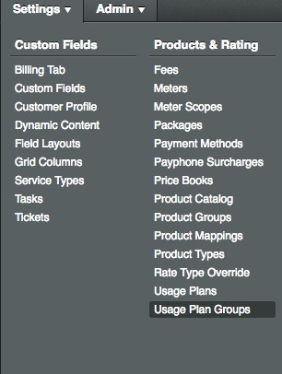 Many Rev.io users will copy data from the rate ×le into the appropriate ×elds of this template. Be sure to save as a .csv ×le before uploading or Rev.io will not accept the ×le.

Creating a Usage Plan Group

1. Usage Plan Groups are a group of Usage Plans applied to a customer's line or service. To create a Usage Plan Group, Go to Settings tab > Usage Plan Groups.

2. Click the Add New button at the top and complete the Description ×eld. This will be the description Rev.io users see in the dropdown list when selecting the rates to apply to the account. Long
Description and PIC/LPIC are optional ×elds.
a. Description - This is the name that will appear in the UI referencing this program.
b. Long Description - This information is for internal use only and can be seen on this screen or available in a report from the table containing this data.
c. PIC/LPIC/IPIC - Not typically used by today's Rev.io users. Formerly used when two separate carriers were delivering the local and long distant service.

3. To add a plan to the Usage Plan Group, select the Plan and click Options > Edit > Add New. Usage Plan Groups can contain as many Plans as needed to create a comprehensive rating tool for the customer's line. Type is an optional ×eld. The default settings for these ×elds are acceptable if not using them.

a. Plan - Plans available for grouping in the Usage Plan Group. These are con×gured under Settings > Usage Plans.
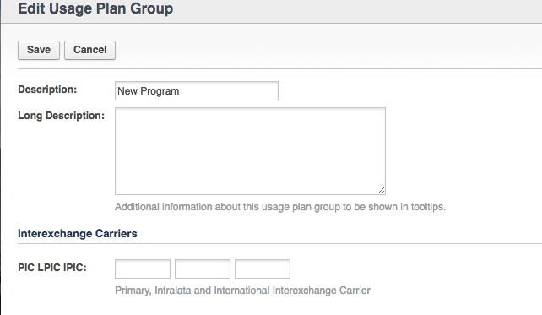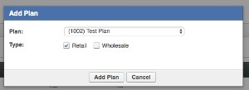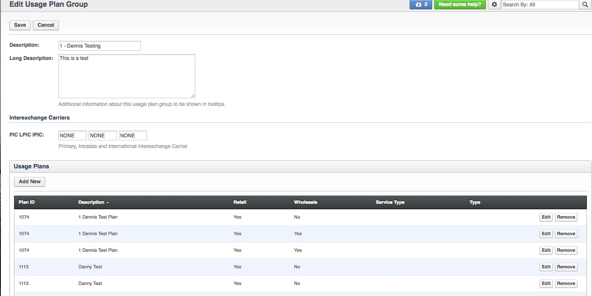b. Type - Retail is traditionally checked for the rates that apply to the customer. Wholesale can be checked if a secondary plan will be used to rate the call a second time and capture a cost that can be used in reporting and comparing against what the customer was actually charged.
4. Click Add Plan to complete the Usage Plan Group.
5. Repeat Process until all plans have been added and then click Save.

noprint

